**Headless Migration Helper**

**Idea:** Our idea was to create Sitecore PowerShell scripts to help the migration process to headless. There are a lot of manual processes to be followed to create the JSS sites(Sitecore site and the client side application) and after you create the sites, you will again have to move/create the renderings and make changes to them. Our idea is to automate this process as much as possible. We tried to break down this whole process in few steps.

**STEP 1:**  We have created a script to generate the parameters needed to build the react/nextjs app.

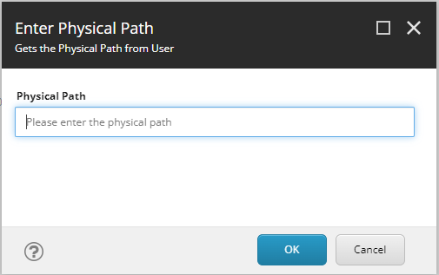

On clicking this option, users will be shown different screens to select jss version, framework type, application name, hostname etc. Once all the values are entered the script returns a JSON that can be copied from the script results.

**STEP 2:** We then move the directory where we want to create the JSS client application. We paste the initializeJSS.ps1 to this directory and create a variables.json file and paste the value we copied in STEP 1. Now if we run the initializeJSS.ps1 app it will create the APP based on the selection in STEP 1

**STEP 3:** We have created one more sitecore powershell script, that will help us to move the controller from the existing site to the Sitecore JSS site

**Installation:**

1. Install the packages Generate JSS App Parameters.zip
2. Select the Site you want to migrate and select the Generate JSS Parameters script from the context menu.
3. Enter the details as asked in the pop-ups and click on the View Script Results.
4. Copy the JSON displayed in the results

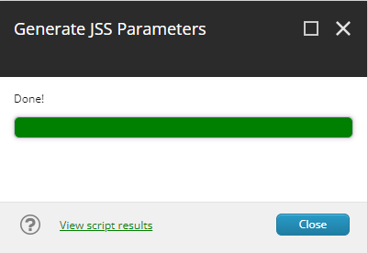

1. Move to the directory where you want to create the app create a variables.json file and paste the JSON copied in the above step. Copy the initializeJSS.ps1.

1. Run the initialize.ps1. The script will create the app and will ask for values when it runs jss setup. These values can be found in the variables.json file. The script will also deply the config and app.
2. Install the Package SitecorePowershellForMigratingRenderingsToJsonRend.Zip

8. This contain basically Custom PowerShell Module which will be installed in Sitecore CM environment

1. The main purpose of this PowerShell module is to migrate controller rendering or view rendering to respective JSON rendering (Modifying existing rendering) or Duplication existing rendering to custom folder specified and converting them JSON rendering.
2. This everything happens through PowerShell Interactive Dialog
3. Custom Folder path can be specified in below format master:/sitecore/layout/Renderings/Feature/JSS Experience Accelerator/Custom
4. The Script execution button is available in View section Content Ribbon Editor name as "ConvertToJsonRendering"

Converting To JSON Rendering:

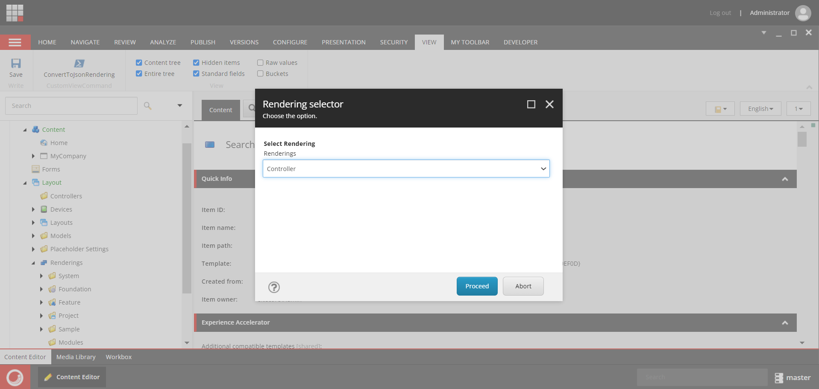

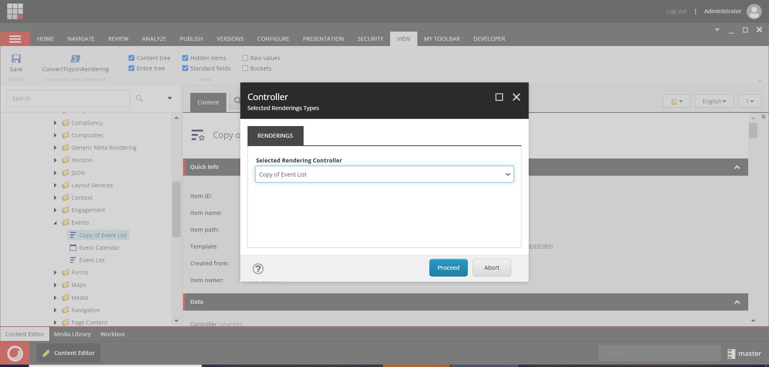

Duplicate existing Rendering and Converting to JSON Rendering



